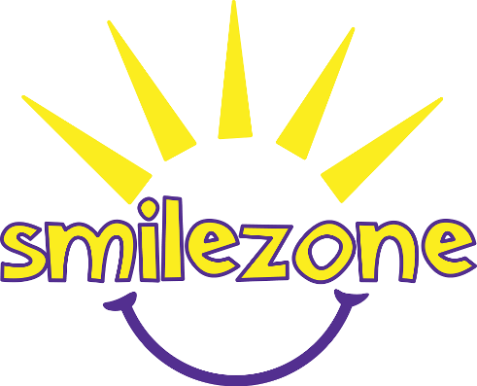
Our mission is to transform spaces in hospitals and health care facilities in order to improve the lives of children facing illnesses, disabilities, and physical or emotional obstacles – ultimately, putting smiles on kids’ faces!

Smilezone Foundation Application

Please complete the following template, and submit via email to Jackie Hames – Operations and Communications Coordinator – at jhames@smilezone.com. Submissions will not be accepted by fax.

All inquiries will be acknowledged by e-mail within one week of submission.

ORGANIZATION INFORMATION

Name of Hospital/Health Care Centre:
_____________________________________________________________________________

Address:
_____________________________________________________________________________

Website:
_____________________________________________________________________________

Contact Name & Position:
_____________________________________________________________________________

Phone Number:
_____________________________________________________________________________

Email Address:
_____________________________________________________________________________

Alternative Contact:
_____________________________________________________________________________

SMILEZONE PROJECT INFORMATION

- How did you hear about Smilezone Foundation?

_____________________________________________________________________________

- What program/department(s) you would like a Smilezone built in:

______________________________________________________________________________

- Description of the current space(s) you would like a Smilezone built in (i.e. Physical characteristics, key features, etc.)

_____________________________________________________________________________

_____________________________________________________________________________

_____________________________________________________________________________

_____________________________________________________________________________

_____________________________________________________________________________

_____________________________________________________________________________

_____________________________________________________________________________

_____________________________________________________________________________

_____________________________________________________________________________

_____________________________________________________________________________

- What changes/improvements would you envision in this space(s)?

_____________________________________________________________________________

_____________________________________________________________________________

_____________________________________________________________________________

_____________________________________________________________________________

_____________________________________________________________________________

_____________________________________________________________________________

_____________________________________________________________________________

_____________________________________________________________________________

_____________________________________________________________________________

_____________________________________________________________________________

PROJECT INFORMATION (continued)

- How many children use this space(s) on an annual basis?

_____________________________________________________________________________

- Demographics of children and families using this space:

_____________________________________________________________________________

_____________________________________________________________________________

_____________________________________________________________________________

- Do you own or lease your facility?

_____________________________________________________________________________

- Do you have any upcoming renovation plans within this space? If yes, please describe & timeline:

_____________________________________________________________________________

_____________________________________________________________________________

_____________________________________________________________________________

- Do you have any upcoming occasions, anniversaries and/or celebrations?

_____________________________________________________________________________

_____________________________________________________________________________

_____________________________________________________________________________

Thank you
Our smilezone Team will be in touch with you shortly!

